COSC 350 System Software: Mini Test #1

09/18/20

Name: Jacob Duncan

1. (1 pt.) Create a file named **numbs** that contains the integers 1 through 100, one integer per line with shell commends with output redirection. The file will have 100 lines. You need use for loop.

For I in {1..100}; do

Echo $I >> numbs

Done

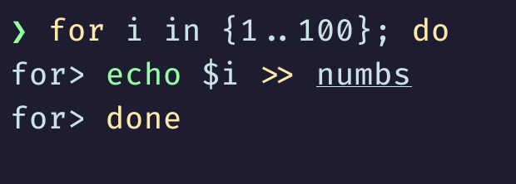

1. (1 pt.) There are two types of libraries: static library and shared library. Briefly explain differences between static and shared library.
   * **Static library: (.s) Also called archives are a collection of object files in a ready to use form. To use these libraries, you must include a header file in your program.**
   * **Shared library: (.ao) The libraries that can be linked to any program at run-time. Once they are loaded once, they can be used on any program because there is always a single copy of a shared library in memory. These types of libraries save space.**
2. (1 pt.) When we pass arguments to a script, system save each arguments in positional parameters $0, $1, $2, … What information will save on each of following positional parameters

* **$@ : List all the parameters in a single variable**
* **$*: List all the parameters in a single variable**
* **$0: First parameter passed (usually the name of the executable)**
* **$#: Number of parameters passed**

1. (1 pt.) What are two conditions to make a shell script file executable
   1. **Provide where the bash shell program is located (!# /bin/bash)**
   2. **Change the script mode to executable (chmod +x ./file_name.sh)**
2. (2 pt.) Since a directory itself is a file in Linux system, each directory has name. Write bash script which test each file names in current directory and display subdirectory names.

**#!/bin/bash**

**For file in *; do**

**If [ -d “$file” ]; then**

**Echo “$file”**

**Fi**

**Done**

**Exit 0**

I coded it in my terminal and took a picture and attached it because the capitalization is

strange in Microsoft Word.

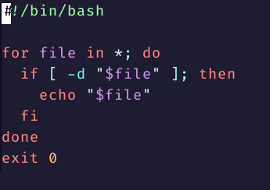

1. (2 pt.) Write a script to calculating factorial of given number by using while loop. The script asks an integer value with read command and calculates factorial and display the result.

**Prompt=”Enter a number to calculate the factorial of (must be positive): “**

**Echo –n “$prompt”**

**Read input**

**Factorial = 1**

**While [ “$input” -lt 0 ]; do**

**Echo “invalid entry, you must enter a positive number”**

**Echo –n “$prompt”**

**Read input**

**Done**

**Temp=$input**

**While [ $input –gt 0 ]; do**

**Factorial = $(($factorial * $input))**

**Input=$(($input –1))**

**Done**

**Echo “The factorial of $temp is $factorial”**

**Exit 0**

I coded it in my terminal and took a picture and attached it because the capitalization is

strange in Microsoft Word.

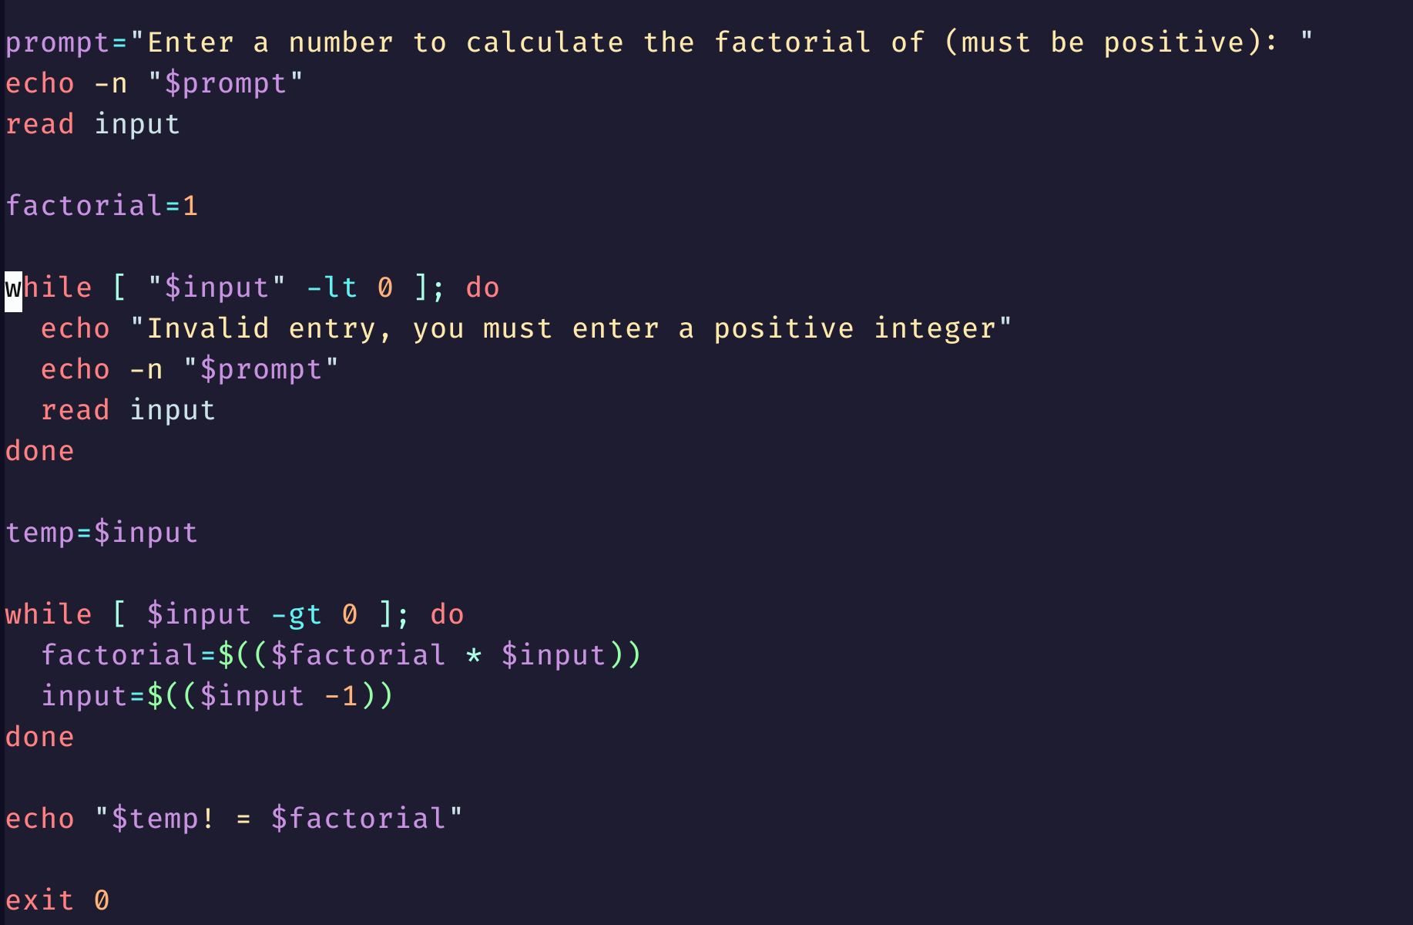

1. (1 pt.) Write shell script by using nested for loop to print the following patterns on screen based on an integer input n (between 1 and 9) from the keyboard. (Do not use (()) in for loop). Your program display following shape with input 6.

1

22

333

4444

55555

666666

**Echo –n “Input number between 1 and 9: “**

**Read num**

**While [ $num –lt 1 –o $num –gt 9 ]; do**

**Echo –n “Error, enter a number between 1 and 9: “**

**Read num**

**Done**

**For I in $(seq 1 $num); do**

**For j in $(seq 1 $I); do**

**Echo –n “$I"**

**Done**

**Echo**

**Done**

**Exit 0**

I coded it in my terminal and took a picture and attached it because the capitalization is

strange in Microsoft Word.

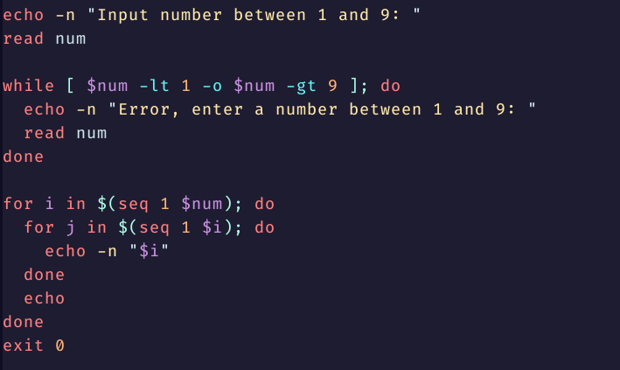

1. (1 pt.) Briefly explain the difference between the following two bash commands:

ls -l | less : **This command will execute the ls –l command and display it in page format where we can view the files and directories page by page.**

ls -l > less : **This command will execute the ls –l command and redirect the output to a file named less.**